# EXPERIMENT NUMBER –Practical 10.1

STUDENT’S NAME – Shinde Smita Shahaji

STUDENT’S UID – 20BCS4643

CLASS AND GROUP –CSE-IOT(GROUP B)

SEMESTER – 2ND

**TOPIC OF EXPERIMENT –**

WAP to copy the contents of one file to another and display it on output screen.

AIM OF THE EXPERIMENT –

Learn how to use file handling in c++

FLOWCHART/ ALGORITHM

Start.

Step 1→ Creating a header file for input output stream and define the context.

# Step 2 → After that used using namespace std;

Step 3 → Creating the function int main() and declaring the source file and target file using * fs and *ft controls how data is stored and retrieved.

Step 4 → using predefined objects cout and cin for the taking input from source file for the output enter the name of file.

Step 5 → using fs = fopen(sourceFile, "r"); we are doing here opening of source file and then providing condition if fs is null then in source file error will occur and output will get on the output screen. Same conditions for the target file.

Step 6 → the fgetc() function returns the read character. On failure it returns EOF. If the failure is caused du to end of the file, it sets the eof indicator.

Step 7 →then providing the condition while(ch != EOF) and after using predefined object printing file is copied sucussesfully.

PROGRAM CODE

#include<iostream>

using namespace std;

int main()

{

char ch, sourceFile[20], targetFile[20];

FILE *fs, *ft;

cout<<"Enter the Name of Source File: ";

cin>>sourceFile;

fs = fopen(sourceFile, "r");

if(fs == NULL)

{

cout<<"\nError Occurred!";

return 0;

}

cout<<"\nEnter the Name of Target File: ";

cin>>targetFile;

ft = fopen(targetFile, "w");

if(ft == NULL)

{

cout<<"\nError Occurred!";

return 0;

}

ch = fgetc(fs);

while(ch != EOF)

{

fputc(ch, ft);

ch = fgetc(fs);

}

cout<<"\nFile copied successfully.";

fclose(fs);

fclose(ft);

cout<<endl;

return 0;

}

ERRORS ENCOUNTERED DURING PROGRAM’S EXECUTION

(Kindly jot down the compile time errors encountered)

When I using online GBD complier its not working.

PROGRAMS’ EXPLANATION (in brief)

1. We start our program with preprocessor (#) and header file (< iostream >) we have many types of header files but in this program, we used iostream. #include< iostream >, Int main () is a function which work as a container of statements. All the statements are enclosed within the pair of braces { }. “using namespace std” means we use the namespace named std. “std” is an abbreviation for standard. So that means we use all the things with in “std” namespace.
2. In this program, inside the main program, create variables char ch, sourceFile, targetFile, and initialize FILE with pointer variable *fs, *D. Take the name of the source ﬁle from the user, then check if it is equal to NULL or not, if yes, then print Error Occurred, if not, then take the name of the target ﬁle from the user, again check if it is equal to NULL or not, if yes, then print Error Occurred, if not, then display the message “File copied successfully.” on the screen.

OUTPUT

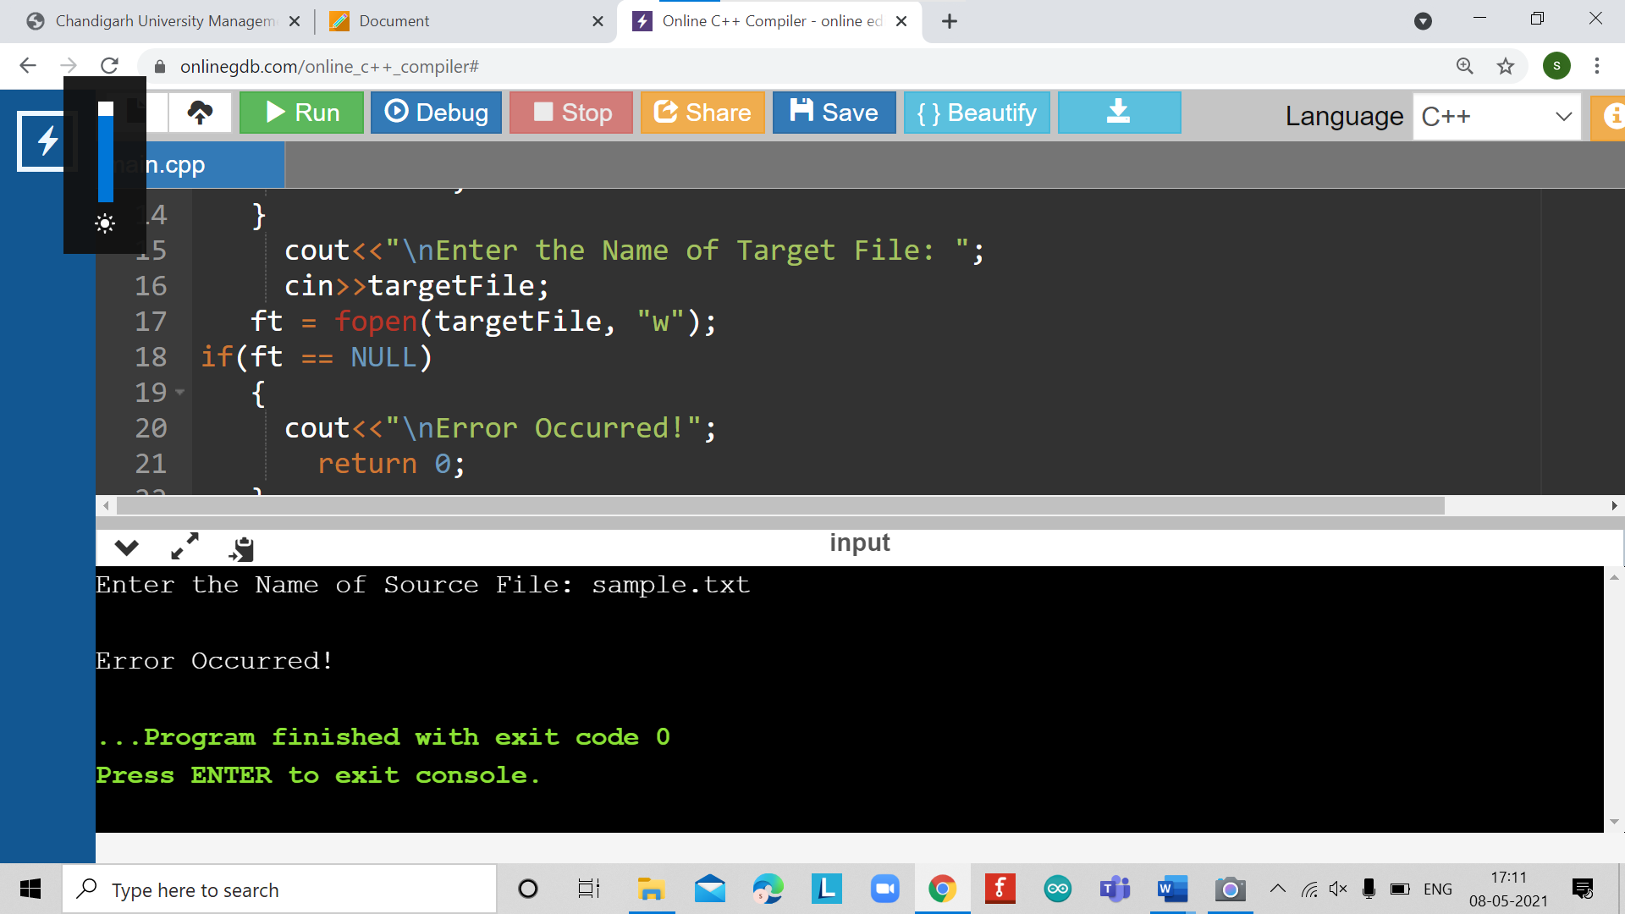

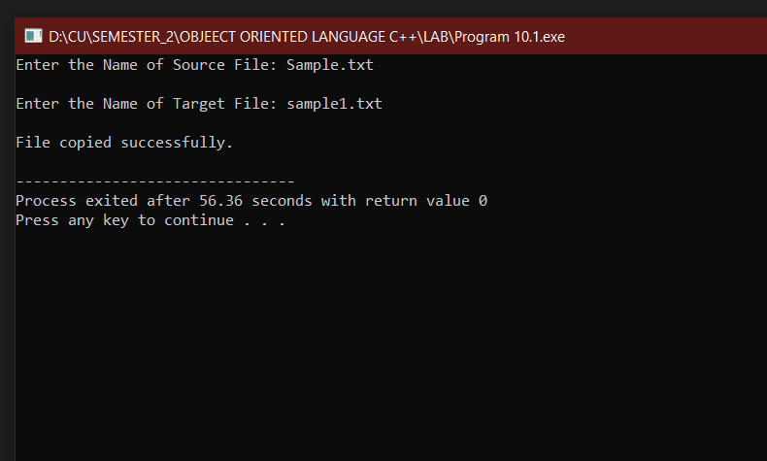

# EXPERIMENT NUMBER –Practical 10.2

STUDENT’S NAME – Shinde Smita Shahaji

STUDENT’S UID – 20BCS4643

CLASS AND GROUP –CSE-IOT(GROUP B)

SEMESTER – 2ND

**TOPIC OF EXPERIMENT – WAP to read the class object of student info such as name, age and roll no from the keyboard and to store them on a specified file using read() and write() functions. Again, the same file is opened for reading and displaying the contents of the file on the screen.**

AIM OF THE EXPERIMENT –

Learn how to use file handling in c++

FLOWCHART/ ALGORITHM-

Start.

Step 1→ Creating a header file for input output stream and define the context and <conio.h > too.

# Step 2 → After that used using namespace std;

Step 3 → create a class student, inside it create variables char name, int age inside private and inside the public one.

Step 4 → create function void getData(void) and ask the user to enter the name and age, the create function void showData(void) to display the entered name and age.

Step 5 → In the main function, initialize student with s, use ofstream ﬁle to open ﬁle in writing mode, if ﬁle is not correct.

Step 6 → then print “Error in creating ﬁle”, otherwise display the message “File created successfully”.

Step 7 → then with s.getData(), read data from user, with ﬁle.write((char*)&s , sizeof(s)).

Step 8 → write into the ﬁle, then with ﬁle.close(), close the ﬁle, aDer that "File saved and closed successfully.

Step 9 → Re-open the ﬁle in input mode and read data, then using ifstream ﬁle again to open ﬁle in read mode.

Step 10 → if it is not correct then print the message "Error in opening ﬁle".

Step 11 → otherwise display data on the screen, at last close the ﬁle.

Stop.

PROGRAM CODE

#include <iostream> #include <fstream> using namespace std;

class student

{

private:

char name[30]; int age;

public:

void getData(void)

{

cout<<"Enter name:"; cin.getline(name,30); cout<<"Enter age:"; cin>>age;

}

void showData(void)

{

cout<<"Name : "<<name<<"\nAge : "<<age<<endl;

}

};

int main()

{

student s; ofstream ﬁle;

ﬁle.open("aaa.txt",ios::out);

if(!ﬁle)

{

cout<<"Error in creating ﬁle.."<<endl; return 0;

}

cout<<"\nFile created successfully."<<endl; s.getData();

ﬁle.write((char*)&s,sizeof(s)); ﬁle.close();

cout<<"\nFile saved and closed succesfully."<<endl;

ifstream ﬁle1; ﬁle1.open("aaa.txt",ios::in); if(!ﬁle1)

{

cout<<"Error in opening ﬁle.."; return 0;

}

ERRORS ENCOUNTERED DURING PROGRAM’S EXECUTION

(Kindly jot down the compile time errors encountered)

No errors are encountered.

PROGRAMS’ EXPLANATION (in brief)

1. We start our program with preprocessor (#) and header file (< iostream >) we have many types of header files but in this program, we used iostream. #include< iostream >, Int main () is a function which work as a container of statements. All the statements are enclosed within the pair of braces { }. “using namespace std” means we use the namespace named std. “std” is an abbreviation for standard. So that means we use all the things with in “std” namespace.
2. In this program, create a class student, inside it create variables char name, int age inside private and inside the public one, create function void getData(void) and ask the user to enter the name and age, the create function void showData(void) to display the entered name and age. In the main function, initialize student with s, use ofstream ﬁle to open ﬁle in writing mode, if ﬁle is not correct, then print “Error in creating ﬁle”, otherwise display the message “File created successfully”, then with s.getData(), read data from user, with ﬁle.write((char*)&s , sizeof(s)), write into the ﬁle, then with ﬁle.close(), close the ﬁle, aDer that "File saved and closed successfully." Re-open the ﬁle in input mode and read data, then using ifstream ﬁle again to open ﬁle in read mode and if it is not correct then print the message "Error in opening ﬁle", otherwise display data on the screen, at last close the ﬁle.

OUTPUT

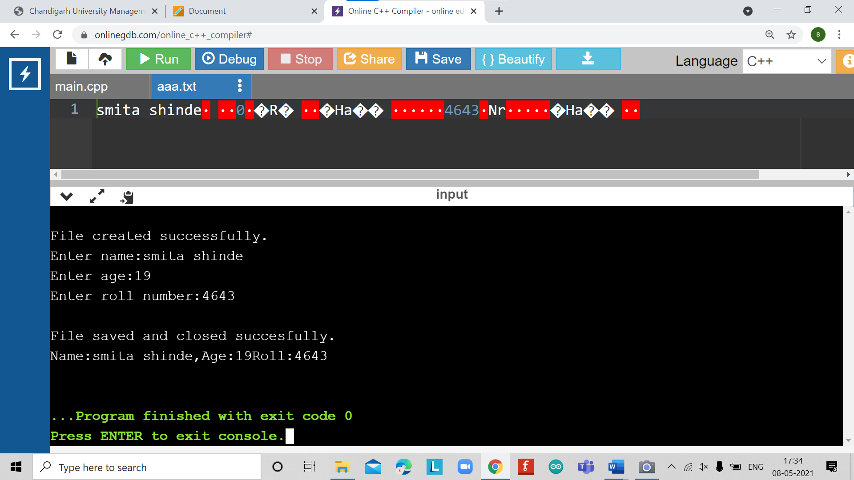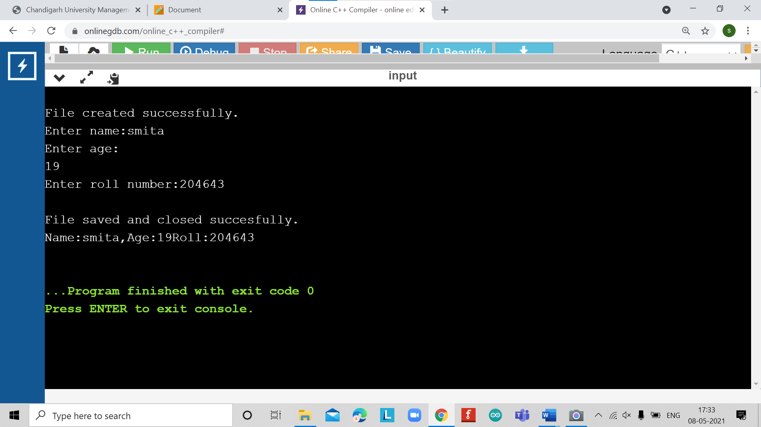

LEARNING OUTCOMES

|  |
| --- |
| * Identify situations where computational methods would be useful. |
| * Approach the programming tasks using techniques learnt and write pseudo-code. |
| * Choose the right data representation formats based on the requirements of the problem. |
| * Use the comparisons and limitations of the various programming constructs and choose the right one for the task. |

EVALUATION COLUMN (To be filled by concerned faculty only)

|  |  |  |  |
| --- | --- | --- | --- |
| **Sr. No.** | **Parameters** | **Maximum**  **Marks** | **Marks**  **Obtained** |
| 1. | Worksheet Completion including writing learning objective/ Outcome | 10 |  |
| 2. | Post Lab Quiz Result | 5 |  |
| 3. | Student engagement in Simulation/ Performance/ Pre Lab Questions | 5 |  |
| 4. | Total Marks | 20 |  |